**Site specific Development Control Plan**

**126 Greville Street, Chatswood and part 25 Millwood Avenue, Chatswood West**

To be inserted within Part D2 Attached Dwellings, Multi Dwelling Housing and Residential Flat Buildings of Willoughby Development Control Plan 2006.

**D.2.16.21 126 Greville Street, Chatswood and Part 25 Millwood Avenue, Chatswood West**

**(Lot 1 DP 532 353 and Lot 1 DP 408490)**

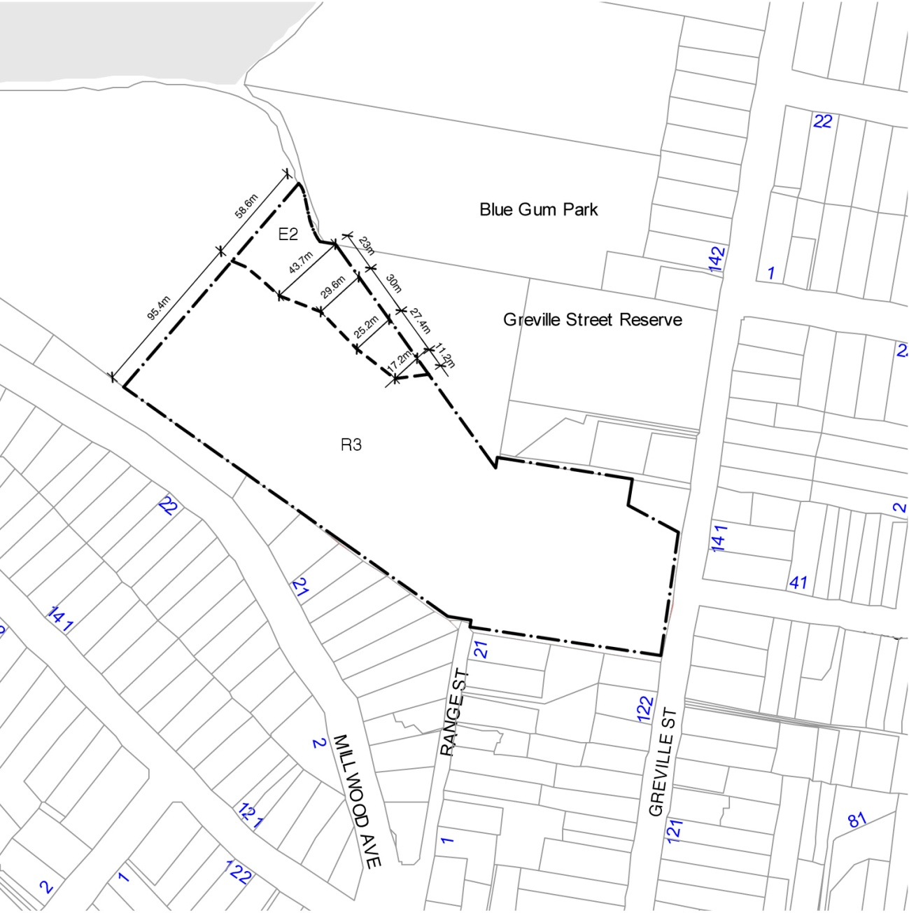

**D.2.16.21.1 Objectives**

1. To ensure that development:

a) does not adversely impact on bushland within the portion of the site in Zone E2 or on adjoining land in Blue Gum Park, Greville Street Reserve or the Lane Cove National Park (by loss of natural vegetation and of significant geological features);

b) includes rehabilitation of native species vegetation along the creek; and

c) does not disrupt drainage patterns, alter water tables or increase bushfire hazard.

2. To minimise adverse impacts on surrounding residential properties, including during the construction period.

3. To ensure that potential site contamination from previous uses on the site is considered prior to any redevelopment.

4. To ensure that the site is planned and developed holistically.

**D.2.16.21.2 Controls**

1. A maximum of 60 dwellings is permitted under WLEP 2012.
2. Should the site be redeveloped as an adaptive reuse of the existing building (as permitted under Schedule 1 of WLEP 2012), car parking in accordance with Council’s traffic and car parking requirements of Part C.4 is required.

Adaptive reuse means that all works related to the adaptive reuse are to occur within the existing external walls and highest points of the existing buildings. In this regard it is accepted that there would be a roof on the highest level of the car park.

1. Building height, form, articulation, spacing and proportions are to respect the streetscape character of Greville Street. Buildings along Greville Street should be articulated to avoid the presentation of a continuous wall facing Greville Street.
2. The Greville Street frontage is to be considered as the primary frontage for dwellings facing Greville Street. In this regard:
3. Any private open space facing Greville Street is to be treated as a front yard,

containing canopy trees.

1. The pedestrian entrance to buildings facing Greville Street is to be provided

from Greville Street.

1. Building setbacks to the site boundaries are to be in accordance with WDCP Part D2 Attached Dwellings, Multi Dwelling Housing and Residential Flat Buildings, Clause D.2.8 ‘Setbacks.’ Buildings within the site may be attached.
2. The redevelopment of the site is to be in accordance with WDCP Part C6 Access, Mobility and Adaptability.
3. The redevelopment of the site is to be in accordance with Clause 6.8 Affordable Housing of WLEP 2012.
4. A Bushland Management Plan, including a Vegetation Management Plan, a Threatened Species Management Plan and a Bushfire Management Plan are to be submitted with the DA. The E2 Zone and riparian corridor around the creek is to be protected and restored in accordance with the Vegetation Management Plan.
5. An ecological report that identifies all threatened and endangered species and ways to maintain them is to be submitted with the DA.
6. An arborist report identifying all trees to be removed and retained under the redevelopment of the site is to be submitted with the DA.
7. Site vehicle access is to be from Greville Street via a single dual carriageway access at the southern end of the street frontage. A Traffic Management Plan is to be submitted with the DA which details how internal safety as well as the safety of entering and exiting motorists can be maximised by way of warning signage and kerb adjustments at the Greville Street access.
8. Vehicular traffic access via Millwood Ave is not supported.
9. Range Road is only to be used for emergency vehicle access and evacuation.
10. Visitor parking is to be provided within the community lot / common land at the rate as specified in WDCP Part C.4.2. Visitor parking is to be grouped in strategic locations throughout the site.
11. Where possible driveway access to garages is to provide sufficient depth to allow vehicle parking.
12. Private internal roads are to be designed to ensure the ability for the operation and turning of service vehicles including garbage trucks, fire trucks etc.
13. Garbage and postal services are to be provided within the site in a manner that does not detrimentally impact on the Greville Street frontage / streetscape.
14. Any fire access road is to remain free of obstruction for the purposes of bushfire protection.
15. Consent will not be granted for development of a dwelling on the land prior to the

provision of a satisfactory Stage 2 Contamination Investigation Report.

1. Impacts on surrounding properties and the natural environment, both within the site and the adjacent national park, during the demolition / construction period are to be

minimised by establishing exclusion zones, preparing and complying with a construction management plan, minimising excavation, dust control, noise management and controlling hours of activity. In this regard a Construction Management Plan is to be provided for all phases of the development.

1. A Traffic Management Plan for all construction vehicles is to be submitted for each phase of the development.
2. The development is to provide a pedestrian environment that is safe and comfortable for pedestriansand where possible wheelchairs. A plan demonstrating through site pedestrian routes is to be submitted with the DA and is to include the provision of paths, shared zones, lighting, signage and surface finishes.

1. Public access is to be provided through the site, and is to connect where possible with bushland trails in Blue Gum Reserve and Greville Street Reserve.
2. The site is not to operate as a gated community.
3. All utility services and cabling shall be located underground.
4. Prior to any construction activities (but not including demolition works), a comprehensive DA is to be submitted for the entire site addressing subdivision layout, subdivision arrangements, building footprints, building envelopes, floor space, access arrangements, number of dwellings, bushfire management, staging etc.

1. Subdivision arrangements for the site must include appropriate measures to ensure proper management and preservation of the riparian corridor and other bushland areas on the site. Details are to be included in any DA that proposes subdivision of the site.

28. The development is to comply with the Planning for Bushfire Protection and AS 3959 - 2009 Construction of Buildings in Bushfire Prone Areas.

29. The internal access road shall have a minimum carriageway width of 6.5m. Suitable turning provisions shall be provided for a tanker at the end of the internal access road and at the first right-hand turn intersection into the eastern precinct. An emergency link vehicular access shall be provided at Range Road.

30. A Bushfire Emergency Evacuation Plan is to be submitted with the DA, in accordance with the NSW Rural Fire Service document Guide for Developing a Bush Fire Emergency Evacuation Plan.